Nepal College of Information and Technology

Level: Bachelor Assessment Exam Year: 2015
Program: BE Full marks: 100
Course: Digital Communication Time: 3hrs
Candidates are required to give their answer in their own words as far as practicable.
The figure in the margin indicates full marks.
Attempt all the questions.
1 | a. | State Nyquist sampling theorems for band limited signal. Find the Nyquist rate for the following message signals.  - M (f) is band limited from 7.0 MHz to 8.0 MHz | 8
 | b. | Show that the Quantization error power in uniform quantization is given by q = Δ²/12, where Δ is the step size. | 7
2 | a. | What do you mean by companding? Why non-uniform quantization is better than uniform quantization? Justify. | 7
 | b. | A PCM system uses a uniform quantizer followed by a 7 bit binary encoder. The bit rate of the system is equal to 50x 10⁶ bits/second. Calculate the message bandwidth for which the system operate satisfactorily and also calculate SQNR when a full load sinusoidal modulating wave of frequency 1MHz is applied to the input. | 8
3 | a. | Define Information, and Entropy. Find the information rate and Entropy of the source S={s1, s2, s3, s4}, the probability of occurrence of each symbols are p (s1)= p (s2)= p (s3)= p (s4)=0.25. | 7
 | b. | Represent the binary data 1010111010000010100001 by the following baseband representation formats:  - Unipolar(NRZ and RZ)  - Polar format  - Bipolar/psedoternary/AMI format  - Manchester Format  - HDB3 signaling | 8
4 | a. | What is ISI? Explain how ISI affect in reliable reception of data in baseband digital communication system with necessary equation. | 8
 | b. | A white-noise process W (t) of zero mean and power spectral density N₀/2 is applied to an RC filter as shown in figure below. Find and plot (not to scale) the autocorrelation of the signal output of the RC filter.  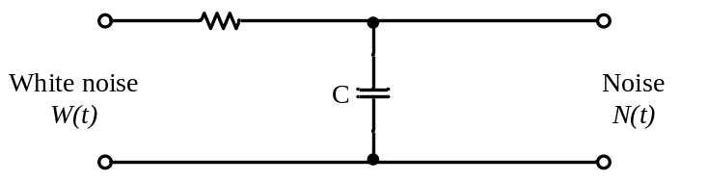 | 7
5 | a. | What is a matched filter? Derive the impulse response h (t) of a filter matched to the signal pulse g (t). | 8
 | b. | Find the expression of error probability for M-array system . | 7
6 | a. | How SNR is improved in FM system using Pre-emphasis and De-emphasis network at the transmitter and receiver respectively? | 7
 | b. | For the (7,4) Linear block code (Hamming code). Find the code word for message bit stream {0110}. If a code is transmitted and the error occurs at 6th bit position, find the corresponding syndrome value.  I _{k}  P  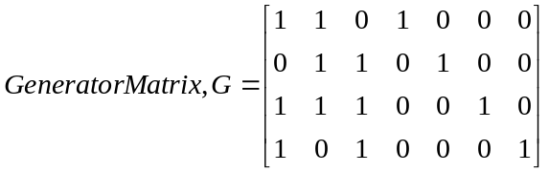  I _{n-k}  P^{T}  and parity check metrics  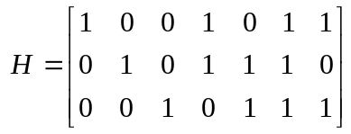 | 8
7 | Write Short Notes on(any two)(2*5)
 | a.  b.  c. | QPSK  Eye Pattern  T1 and E1

